Game and Level Design
2019 - 2020

GAME AND LEVEL DESIGN – LEVEL DESIGN DOCUMENT

Up to Eleven

-idiom from popular culture, coined in the 1984 movie ‘This Is Spinal Tap’
-represents the act of taking something to an extreme

-suggests that the outcome is all in the hands of Eleven



Unusual Events

Cristian Iacovlev 953989 cristian.iacovlev@studenti.unimi.it
Daniele Fiorenza NA daniele_fiorenza@live.com
Riccardo Graziosi NA riccardo.graziosi97@gmail.com
INDEX

High Concept 4

Settings 5
Locations 5

Synopsis of the story 6
Act 1: Exposition 6
Act 2: Rising action 6
Act 3: Climax 6
Act 4: Falling action 6
Act 5: Denouement 6

Themes 7

Story and world diagram 8
Level 1: Cage. 8
Level 2: Abusive. 8
Level 3: Troubles. 9
Level 4: Alive. 9
Level 5: Sunken. 9
Level 6: Trash. 9
Level 7: Roll. 10
Level 8: Otherworldly. 10
Level 9: Predator. 10
Level 10: Helpless. 11
Level 11: Eleven. 11

Characters 12
Eleven
Description 13
Circumplex 14
Relationships Map 14
Dr. Martin Brenner
Description 15
Circumplex 16
Relationships Map 16
Mike
Description 17
Circumplex 18
Relationships Map 18
Dustin
Description 19
Circumplex 20
Relationships Map 20
Lucas
Description 21
Circumplex 22
Relationships Map 22
Demogorgon
Description 23
Circumplex 24
Relationships Map 24
Corrupted Eleven
Description 25
Circumplex 26
Relationships Map 26
Pure Eleven
Description 27
Circumplex 28
Relationships Map 28

Goal Outline 29

Level 4 – Alive 30
Level story overview 30
Voice lines 32

High Concept

Up to Eleven is a 5 hours long third-person adventure game in which the player controls the main character Eleven along a linear route. Inspired by the question “What happened to Eleven after defeating the Demogorgon?” in episode 8, season 1 of Stranger Things, it’s a psychological horror game that explores the depths of Eleven’s frazzled mind after the prior intense abuse of her powers.
Confined in her own mind, this oniric trip challenges Eleven to hold fast or succumb to a feral madness, bringing to light her deepest fears. The self-consciousness of having caused a lot of deaths because of her bond with what lives on the other side, the fear of being abandoned for her frightening and unpredictable power by the people she loves the most and the overall regret of some of her actions are the topics that, mixed together, bring to life a dark and sad projection of Eleven life experiences. Full of puzzles and inspired by the 80’s arcade games (but adapted to modern gaming standards), Up to Eleven ties together the retro vibes of Stranger Things with a more psychological take, aiming to a mature and emotionally-aware audience. Dantean and allegorical, Eleven’s journey through her own mind is full of throwbacks to the original series, and guides the player to iconic places all revisited according to the “sins” she thinks to have committed in her life, or that she thinks she could commit.

Settings

The main setting of the game is the Upside Down, an alternate dimension that exists in parallel to the human world. More specifically, the game is set in Eleven’s oniric representation of the Upside Down version of Hawkins, a small town located in Indiana. The connection between the Upside Down and the real world was created during an experiment hosted at Hawkins National Laboratory, where Eleven made interdimensional contact with a Demogorgon and unintentionally opened the Gate between the two dimensions.

Locations

Hawkins National Laboratory, a federal complex under the administration of Dr. Brenner. Controlled by the CIA, the lab hosts mental powers experiments.
Hawkins Middle School, the school that Mike, Will, Dustin and Lucas attend.
A complex Tunnel System sprawled beneath the outskirts of Hawkins, with spores floating through the air and vines covering every surface.
The Junkyard, a place mainly filled with abandoned and broken down vehicles that the group first discovered when they were searching for the Gate to the Upside Down. Lucas and Mike fought there over Eleven bad behavior.
The Wheeler House is Mike’s residence. It has a big basement where Mike and his friends usually play Dungeons and Dragons.
The Void, a visual representation of Eleven's mind and appears as a vast endless expanse of nothingness with the floor is covered in a thin layer of water.
Hawkins Public Library, a building located in the center of Hawkins' town square where the Demogorgon brought its victims, appears to function as some sort of nest.
Pumpkin patch, an agricoltural field located in the outskirts of Hawkins, near Hawkins Middle School.
Lovers' Lake, a heart-shaped lake located in the northern part of Hawkins, near the junkyard.
Railway in the forest, a portion of the derelict railway that pass through a forest in Hawkins.
Synopsis of the story

Act 1: Exposition
Eleven is confined by her father, Dr. Martin Brenner, into her room. After she escapes, she finds out that it was the Upside Down version of the laboratory. She later finds her father and confronts him, resulting in the death of Dr. Brenner.

Act 2: Rising action
Mike, Dustin and Lucas, who witnessed the scene, start telling her she's a monster. Devastated, Eleven starts to flee while the guys begin to chase her. First, she finds herself fighting against Dustin (that dies while the school is collapsing), and then she fights Lucas.

Act 3: Climax
While she’s fighting against Lucas, the Demogorgon shows up and captures him. Eleven decides to reach out to Mike, asking for help, but she gets rejected and labeled as a liar. Defeated, she stops trying to do anything, fainting on the ground.

Act 4: Falling action
Eleven reaches the Void, gradually losing parts of her human self and slowing becoming the Demogorgon. She then finds and fights the real Demogorgon, killing it. She later comes back to Mike’s house and fights him again, killing him.

Act 5: Dénouement
After she shed a tear on the dead body of her friend, a light source begins to shine and a copy of Eleven emerges from it. The copy attacks Eleven, and they fight until the corrupted and Demogorgon-like Eleven is defeated. The good copy cleanses the evil one, and they both reunite into one. After a bit, the real Eleven wakes up into the real Upside Down, with no recollection of what happened.

Themes

Loneliness: the lonely wandering in the toxic aura of the upside down’s wasteland, without anyone to count on, creates a harsh feeling. Empty, dilapidated and post-apocalyptic-like buildings contribute to the allegory of Eleven’s emotions.

Confinement: represented in the first place by Eleven’s father imprisoning her in her own room, gets a more broad meaning with the overall confinement in the otherworldly Upside Down and, lastly, in her own mind.

Guilt: the feeling of being a burden and the epiphany of how much death surrounded her actions resulted in a guilt-trip in Eleven’s mind, creating a whole story in which she was the bad guy. The guilt reaches its climax after Eleven kills her own father in front of her friends.

Rejection: strictly tied with the feeling of guilt, the feeling of not being enough for others and the fear of being left alone, abandoned, fueled her fear of being an aggressive and unlovable monster. We can see how she pictures her friends rejecting her for causing nothing but death all around her.

Duality: the duality of human beings, the fight against each person’s own inner beast. This theme is explored with the presence of the Demogorgon and the inevitable fight that will turn Eleven into the beast herself after an extremely gory battle.

Catharsis: the process of releasing, and thereby providing relief from, strong or repressed emotions. The climactic conclusion, the final showdown between the good and the bad side of herself, with the following purification of her frazzled mind.

Story and world diagram

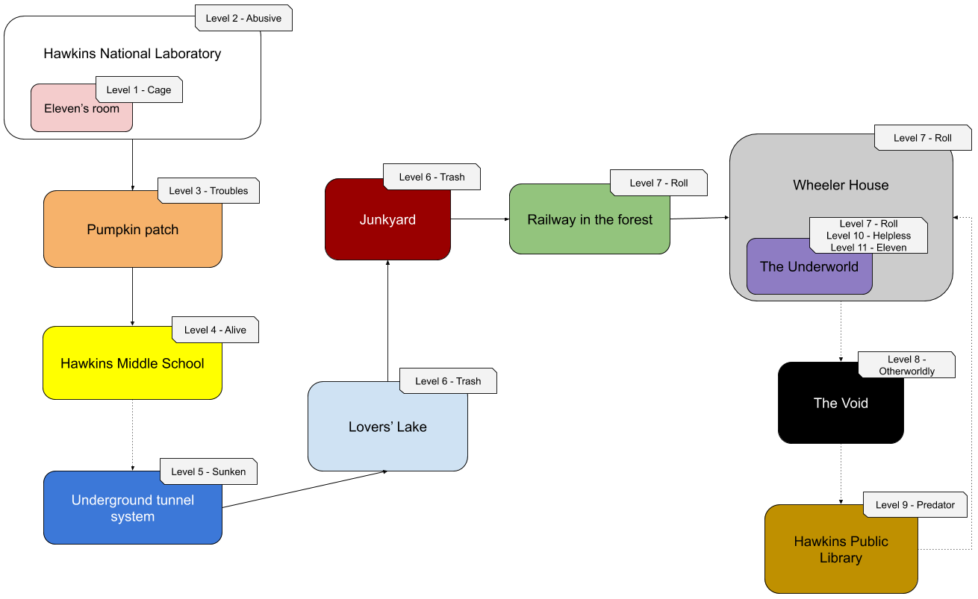
- Level 1 - Cage | (10 minutes)
  - Eleven wakes up, finding herself trapped into her room, inside the Hawkins National Laboratory. Her "father", Dr. Brenner, shows up and scolds her for escaping, telling her that the punishment will be being locked inside her room forever.
  - Eleven uses her powers to escape, only to find out that her reality was an illusion: all the walls collapse like a broken glass, revealing dark and mildewed walls underneath. She was actually being trapped into the Upside Down version of her room.
- Level 2 - Abusive | (30 minutes)
  - While searching for the exit, Eleven bumps into her father and confronts him, saying that she should be free to go because he doesn't own her. That escalates in a battle, were she's trying to fight for her freedom.
  - The battle ends with Eleven killing Dr. Brenner. As his corpse starts to rot, the Laboratory begins to vanish.
- Level 3 - Troubles | (10 minutes)
  - New voices enter the scene: Mike, Dustin and Lucas, representing her consciousness, start telling her she's a monster, she killed her own father, and that she doesn't deserve anything in her life.
  - Devastated, she starts to flee running through a pumpkin patch, while the guys hop on their bikes and initiate a real death-threatening chase.
  - Eleven is able to lose them for a bit, and finds shelter inside the Hawkins Middle School. After a bit, she hears the boys talking outside: Dustin is saying to leave and let him work, so he can capture their prey.
- Level 4 - Alive | (45 minutes)
  - Suddenly the school becomes full of Dustin's high-tech robots: Eleven has to sneak past them in order to escape from the school and be safe. Just as she's trying to reach the gym window to escape, she gets busted by Dustin, that starts attacking her.
  - While she's trying to dodge and deviate his attacks without hurting him, she doesn't realize that the structure can't hold on for much more: as walls start to deteriorate, she tries to leap forward to save Dustin, only to see him getting crushed under the bricks.
- Level 5 - Sunken | (45 minutes)
  - A few moments later, the floor starts to rumble and breaks: Eleven is now free-falling into the darkness. She hits her head and faints, but after a bit she wakes up: she finds herself into a dimly lit tunnel, full of spores and strange vegetation. She wanders through an apparently never ending tunnel system, and finds a way out that takes her near a lake.
- Level 6 - Trash | (20 minutes)
  - Near the lake, she spots Lucas and Mike in the process of looking at the horizon with their binoculars: she hears them talking about the big white smoke that's coming out of the school, and how they hope Dustin is ok. Suddenly, Lucas turns around and discovers Eleven spying on them: he quickly tells Mike to ride his bike as fast as he can, and they run away from Eleven.
  - Eleven, that has every intention to explain her friends they got it all wrong, starts to climb up the hill. After a bit, she catches up to Lucas and Mike in the junkyard: Lucas yells mike to escape, "sacrificing" himself to stop Eleven.
  - They start to fight, and here Eleven understands that he will never reason with her. So, she starts to deflect Lucas attacks back, injuring him. After a long fight they hear a terrible sound and the Demogorgon jumps out of nowhere only to capture Lucas.
- Level 7 - Roll | (45 minutes)
  - Eleven doesn't really know what to do, but she decides to set apart her conflict with Lucas and starts to chase the Demogorgon costing the railway track inside the forest to try to save her friend. Unfortunately she loses line of sight with the monster.
  - Eleven starts to look around, searching for something useful, and notices a faint trail similar to what a bike would leave on leaves. Using her power to detect the source, she finds out that Mike was the rider of the bike, and she follows the track to his house. Here, Eleven finds out that Mike's house wasn't how she remembered it, and that it resembles a lot more a castle.
  - Entering the castle, she has to search for the keys to "the Underworld" (the basement), where Mike is waiting for her. As she arrives there, Eleven tries to convince Mike that she needs his help to rescue Lucas from the Demogorgon, but Mike doesn't believes her: he says that she's a liar, that she's a monster because she killed all his friends, and he starts to attack her.
  - In this battle, all the rejection gets to Eleven's mind, making her feel defeated and unwilling to fight. The more the encounter goes on, the more delay Eleven actions will have, in an unwinnable battle that results in defeat.
- Level 8 - Otherworldly | (15 minutes)
  - As she's defeated, her vision starts to go black. She keeps hearing all the insults her friends said to her, as she finds herself floating into the Void. Her head hurts, a static noise becomes unbearable: she screams, and her face opens like a flower, just like the Demogorgon. As she reaches the ground, covered with a thin layer of water, she discovers a new, feral power inside her. She gets attacked by monsters, but she easily kills them all.
- Level 9 - Predator | (35 minutes)
  - After the brief fight is over, the Void dissipates, leaving her inside the public library. That's the Demogorgon lair, as she quickly assumes by the corpses and skeletons she finds on the ground. She decides to follow the noise to find the Demogorgon and end it all alone. As she discovers where it is at, she finds it eating Lucas' dead body: furious, she attacks it and kills it.
  - While she's now feasting over the Demogorgon corpse, a sound interrupts her: Lucas' walkie-talkie starts buzzing, and Mike voice starts asking him if he's all right, where he's at, if he can hear him. Eleven picks up the device, then uses her power to track down the source of the sound, and starts digging a tunnel to reach her destination (as the Demogorgon would).
- Level 10 - Helpless | (15 minutes)
  - She reaches once again Mike's house, and descends to the basement. She feels feral, she feels angry, she feels betrayed. She can't stop herself. Eleven attacks Mike, resulting in a brutal battle with Eleven as the winner.
  - After she has killed him, Eleven screams again, opening her face as a flower. She looks down to her late friend and, even over all the anger, she shed a tear. As the tear drops, hitting the floor, a bright light begins to illuminate the room, cleansing the toxic aura and the rotten vegetation. From the light source, a copy of Eleven sprouts.
- Level 11 - Eleven | (30 minutes)
  - The two Eleven find themselves into a pure white copy of the Void. The copy starts approaching the protagonist, focussed and ready to fight. A battle starts, where Pure Eleven uses light rays to hit our Corrupted Eleven. After the first phase ends, both Eleven stop for a second: Pure Eleven says "this ends now" and she starts shining.
  - The camera starts moving, passing from Corrupted Eleven to Pure Eleven. As it reaches the middle, we start to see what Pure Eleven is seeing: Corrupted Eleven is nothing more than a Demogorgon now. This last phase of the fight is played as Pure Eleven, with new strong light powers.
  - After she defeats the corrupted version of herself, we see how she purifies her evil copy in a cathartic ending cutscene, hugging her tightly and then proceeding to assimilate her into herself. We get flashed by a bright white light that quickly turns to black, as Eleven wakes up into the real Upside down, with no recollection of what happened inside her own mind.
Characters
The following section is a thorough overview of every main character appearing throughout the game. For the sake of clarity, there will be a heavy use of icons instead of always writing the character’s name. The key to understand which icon belongs to which character is below.
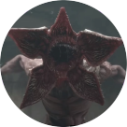Demogorgon
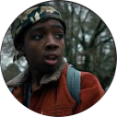Lucas
Dustin
Mike
Dr. Martin Brenner
Eleven
Corrupted Eleven
Pure Eleven
Eleven
Description
Eleven is a 12 years old girl whose childhood was irremediably tore apart. Her main behavioral traits derive from the deprivation of contact with society she was forced into since she was kidnapped as an infant and raised in the Hawkins National Laboratory. Therefore, she is always timid and extremely cautious of other people, besides the fact that her understanding of basic human social constructs is abysmal. This creates a lot of situations throughout her newfound life, once escaped from confinement, that are nearly impossible for her to safely traverse.
From a psychological point of view, her experience carved in her conflicting instincts: she is terrorized by the thought of returning to captivity, but she is also petrified by loneliness, which means she both desperately needs but also often avoids human contact. Nevertheless, she is tightly tied to Mike and his friends, and recurrently shows extreme loyalty to the group and deep feelings for Mike.
She wanders around in a worn-out Polly Flinders brand pink dress and a blue jacket directly over it. Her hair is so short she is almost bald, and her general look is dirty because of her recent escape from the laboratory. She knows the Demogorgon and has just used her powers to annihilate it when our story begins.
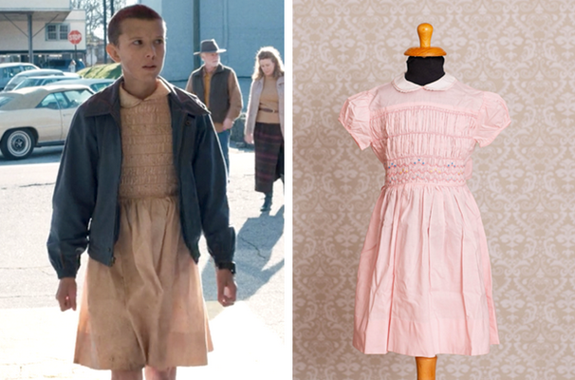Image of Eleven’s look we want to replicate from season 1 of Stranger Things.
Credits: Netflix, LunaGirlVintage.
Circumplex
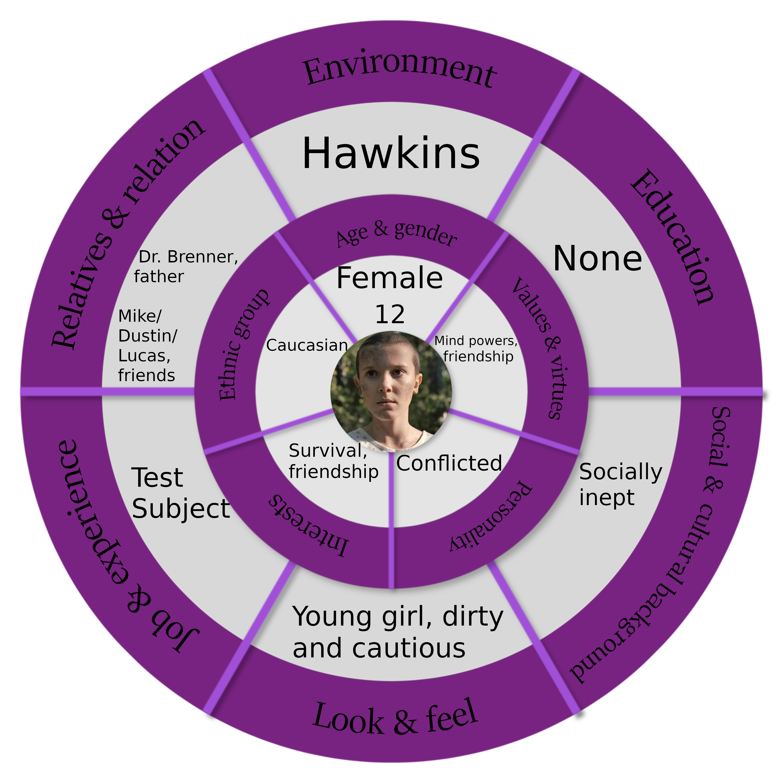

Relationships Map
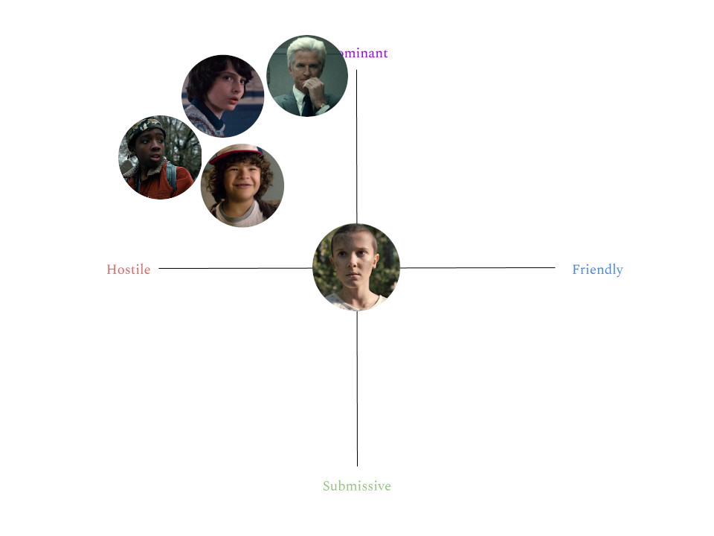
Dr. Martin Brenner
Description
Dr. Brenner is a tall (1.91m) white-haired research scientist employed as a director in the Hawkins National Laboratory. He is responsible of the abduction of Eleven and imposes her to refer to him as “Papa”, besides hiding her true name from her and making sure she knows her status as a test subject and is treated accordingly. His main goal is to make Eleven develop her psychic and psychokinetic abilities because of the secret project MKUltra he is involved into. To achieve this, after imposing himself as a paternal figure for Eleven, he decides the best course of action is to become an emotionally abusive father, by psychologically mistreating her and seldom listening to her needs. When Eleven’s mother set out to look for her, and managed to break into the laboratory, he captured her and subjected her to electroshock therapy, which left her in a seemingly permanent catatonic state.
His appearance resembles that of a common middle-aged man (50 years old) with white hair, but there’s clearly something in his behavior and look that suggests he doesn’t really feel empathy for other human beings. This is enforced by his clothes: he always wears an elegant suite and seems to just have attended a formal meeting for an evil organization.

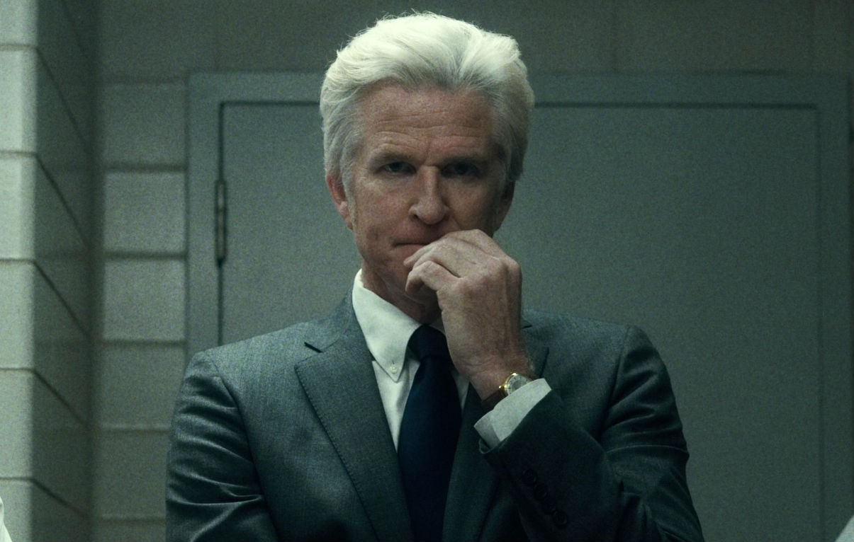Dr. Brenner as seen in the series.
Credits: Netflix.
Circumplex
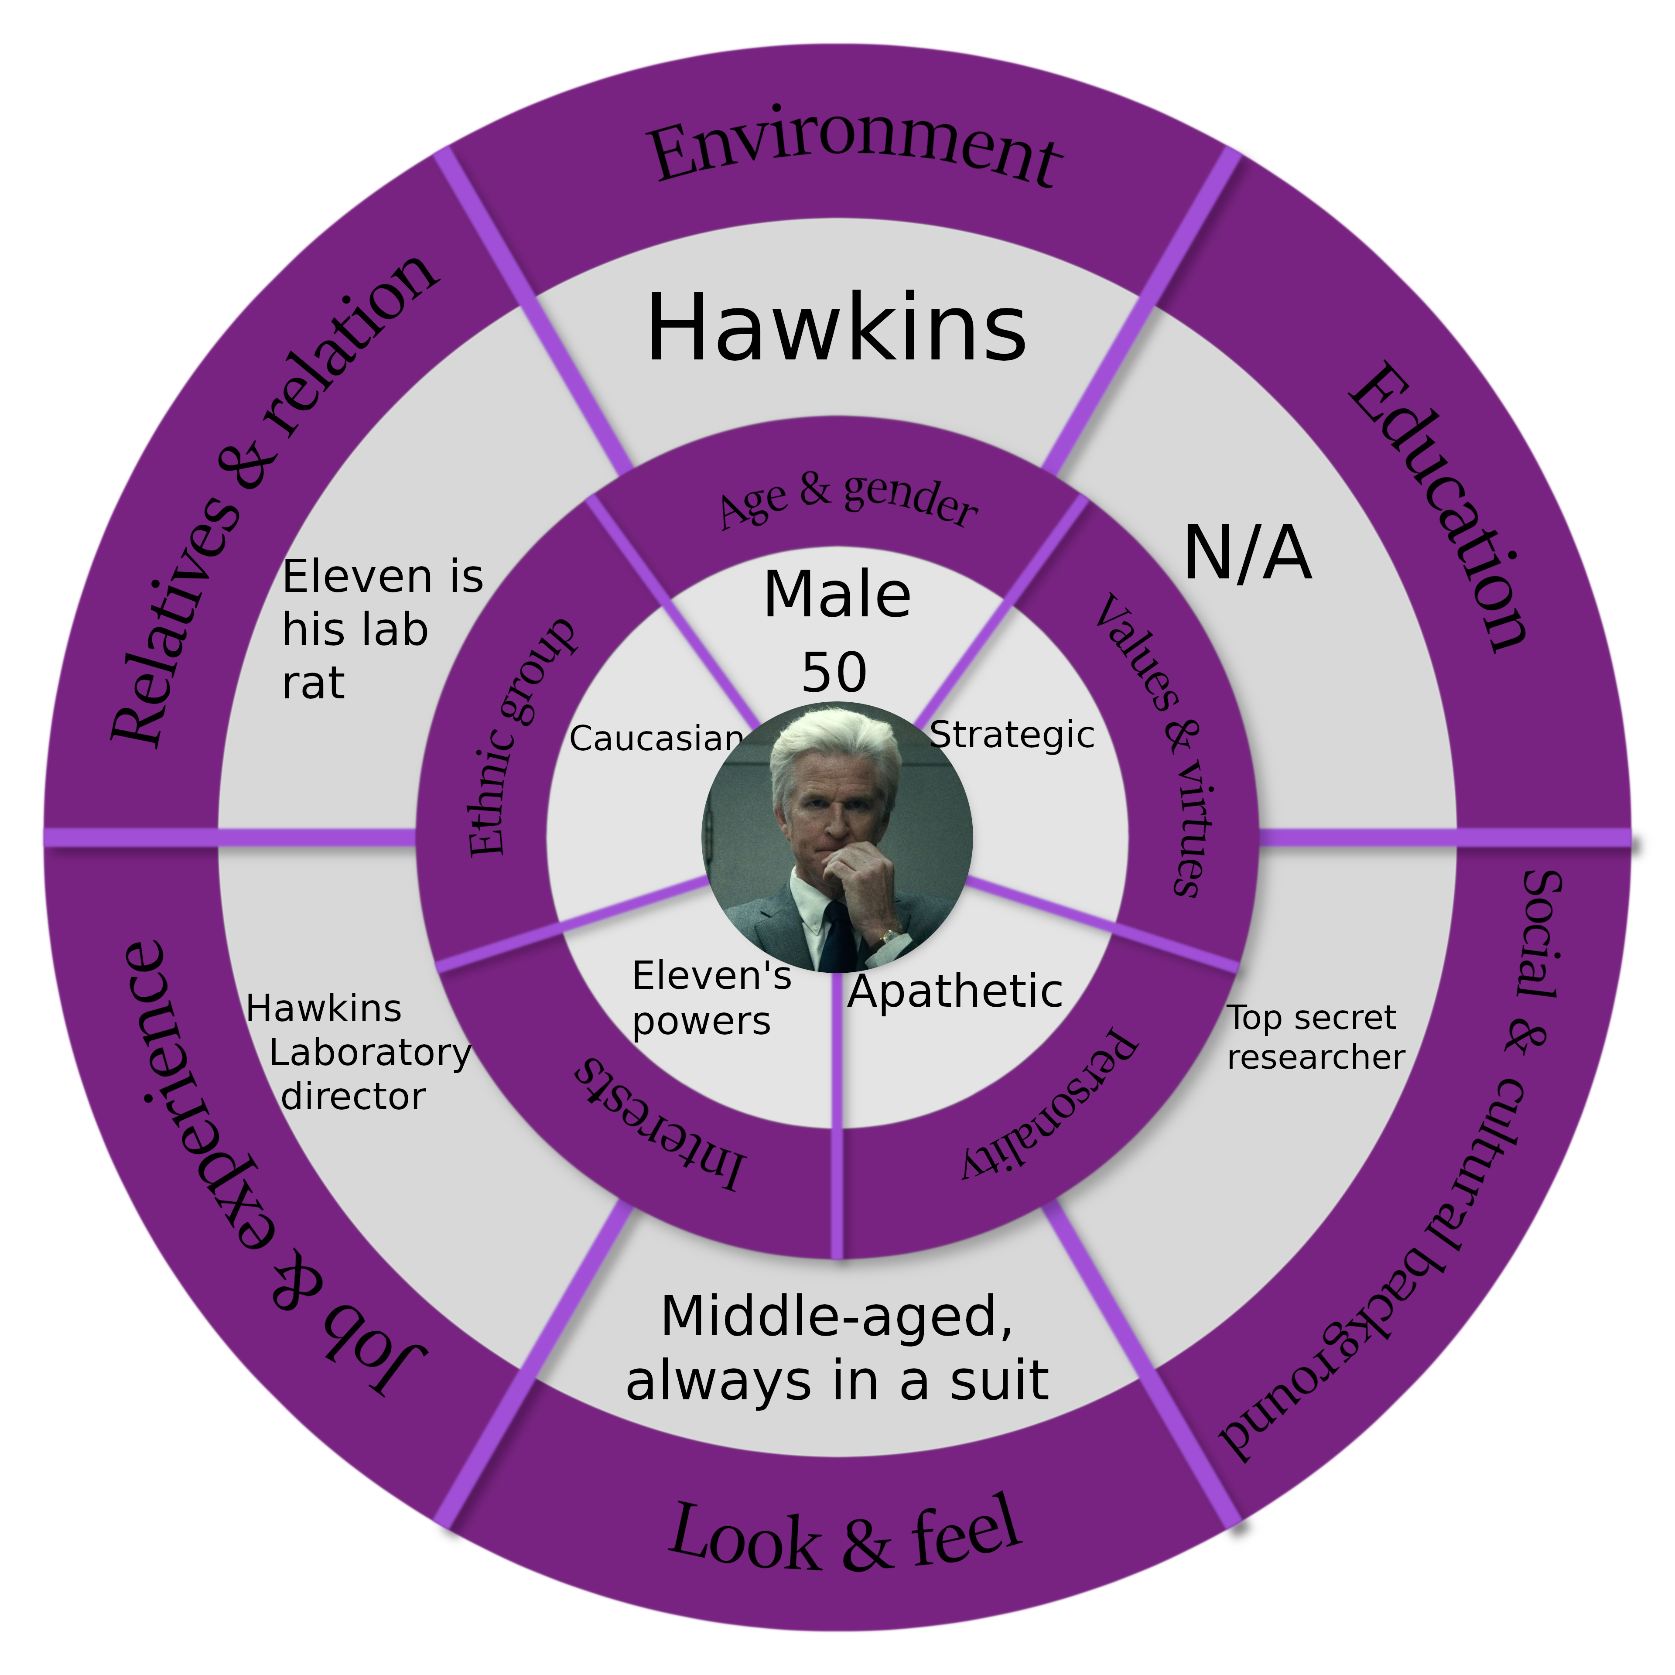

Relationships Map
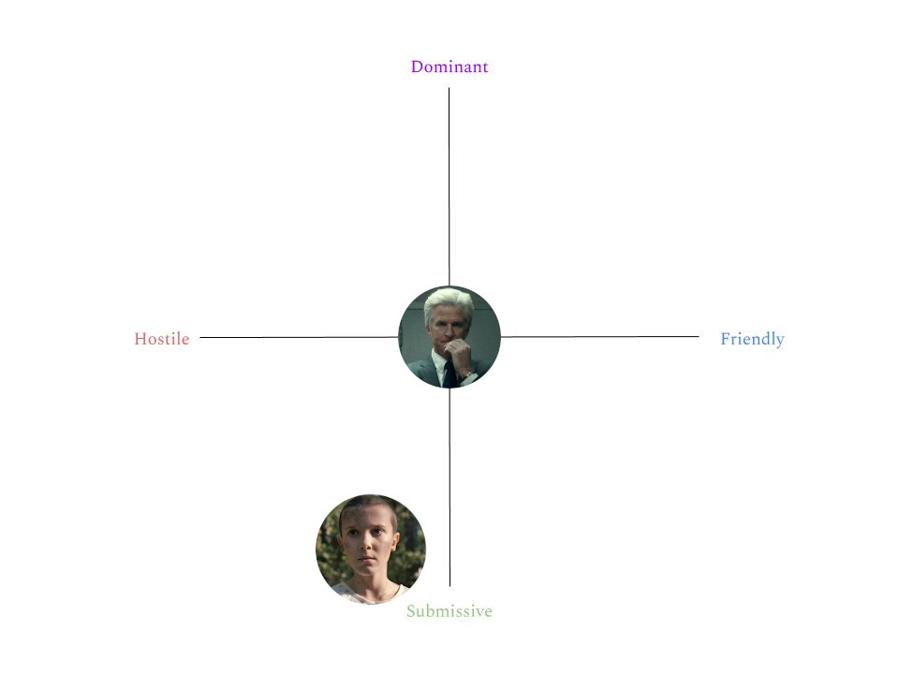
Mike
Description
Mike Wheeler is a young boy that attends Hawkins Middle School. He has medium length brown hair and usually wears a striped polo shirt. He is kind-hearted, sensitive and committed to his friends. He loves playing Dungeon & Dragons with them as the paladin or Dungeon Master. Mike has a trusting nature: when the group finds Eleven, he is the only one who wants to protect and help her. He also is kind of gullible. Indeed, sometimes he is the only one who accepts fantastical explanations. His commitment to friends is openly expressed: in fact, he usually repeats “Friends don’t lie”, a mantra of the group. There is only one time, after Eleven accidentally hurts Lucas, where Mike is angry at Eleven. This game, however, being Eleven’s nightmare, only portraits the worst parts of Mike. In particular, Mike rejects Eleven insistently through the game, asking “What is wrong with you?”, a phrase that Mike repeats a couple of times to Eleven when he is angry at her.

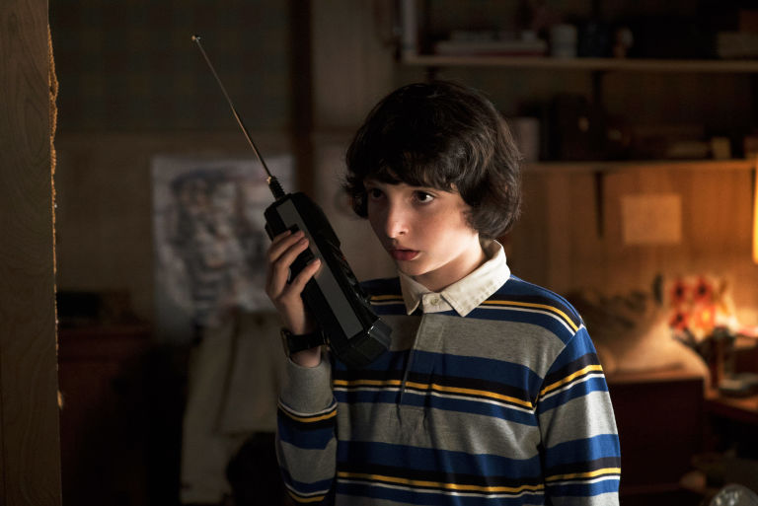Mike with his walkie-talkie.
Credits: Netflix.
Circumplex
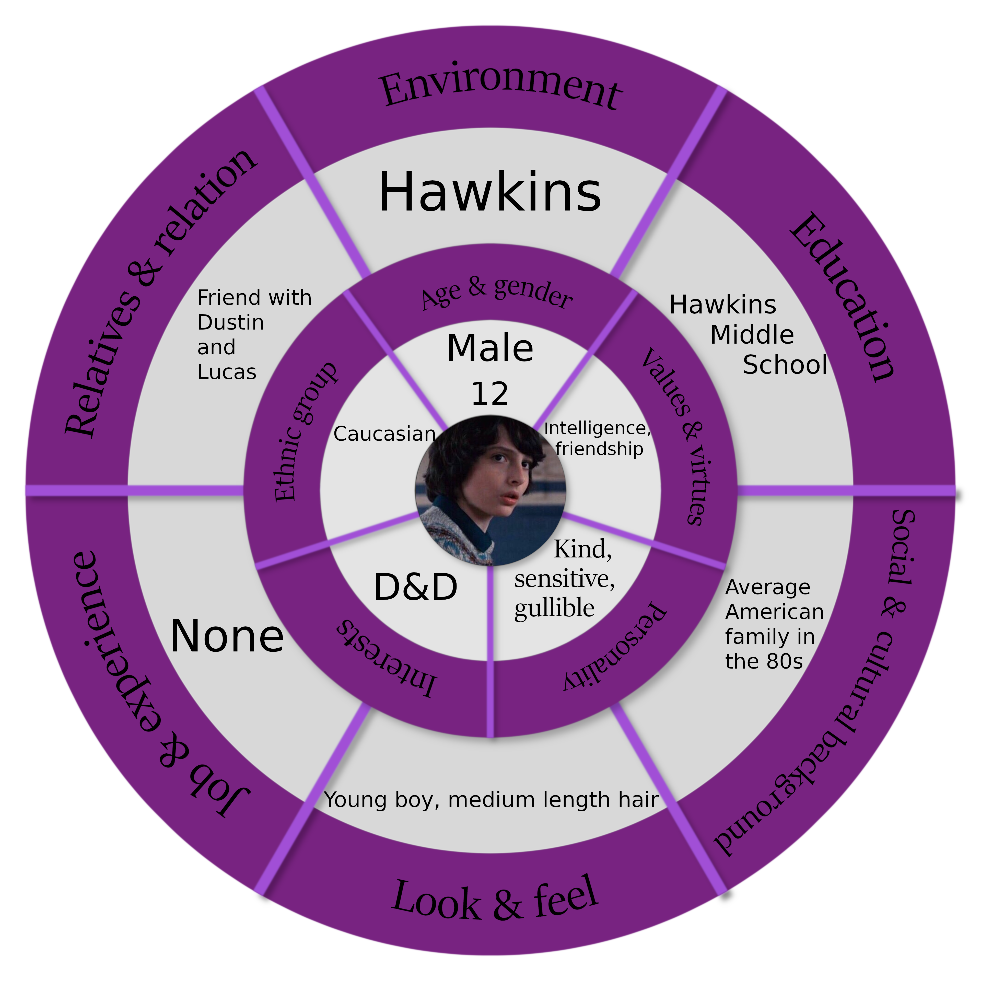

Relationships Map
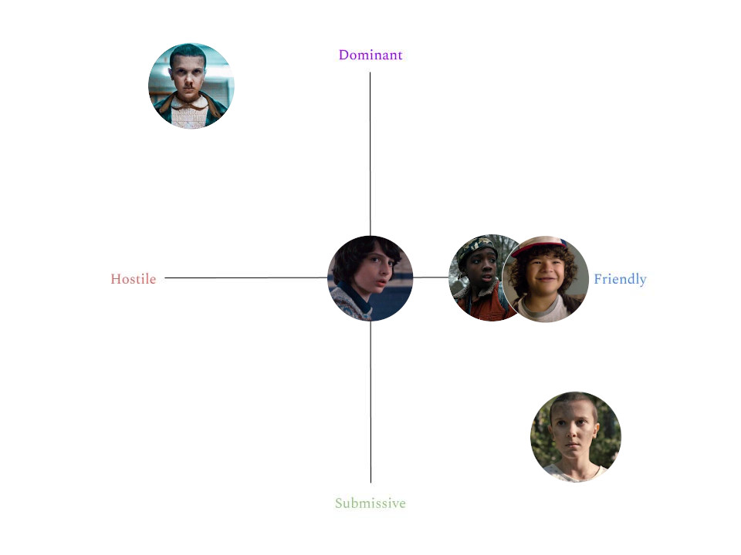
Dustin
Description
Dustin Henderson is one of the member of Mike’s group of friends and attends Hawkins Middle School. He met them when he started attending fourth grade after moving to Hawkins, so he is the most recent acquisition of the party. Dustin has curly hair and usually wears a hat.
He is level-headed and often acts as a negotiator between Mike (which is gullible) and Lucas (which is often too skeptical). This is particularly true in their relationship with Eleven: while Mike is maybe too open to her and Lucas too aloof, he tries, from time to time, to take the smartest position that will benefit the whole group. He usually takes a neutral position, in order to try to keep the group together. Dustin is also the one who pays the most attention to the environment and usually warns his friends of possible incoming dangers. He is the more scientifically inclined of the group, in particular he has a passion for robotics.

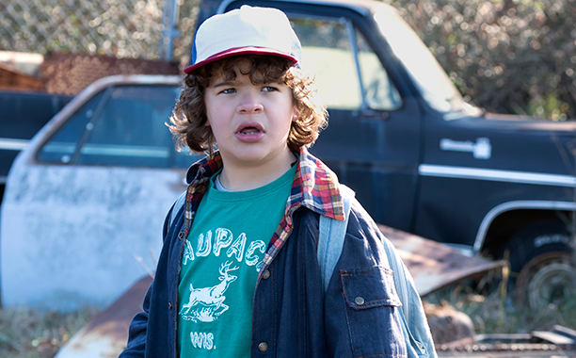Dustin in the Junkyard.
Credits: Netflix.

Circumplex
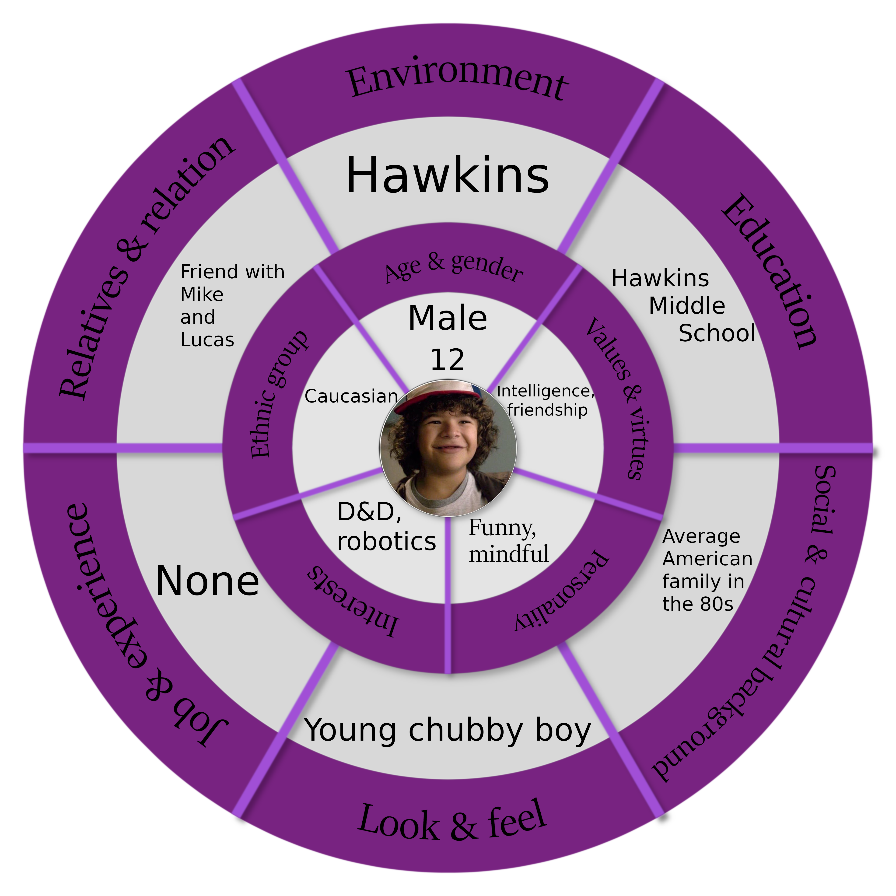

Relationships Map
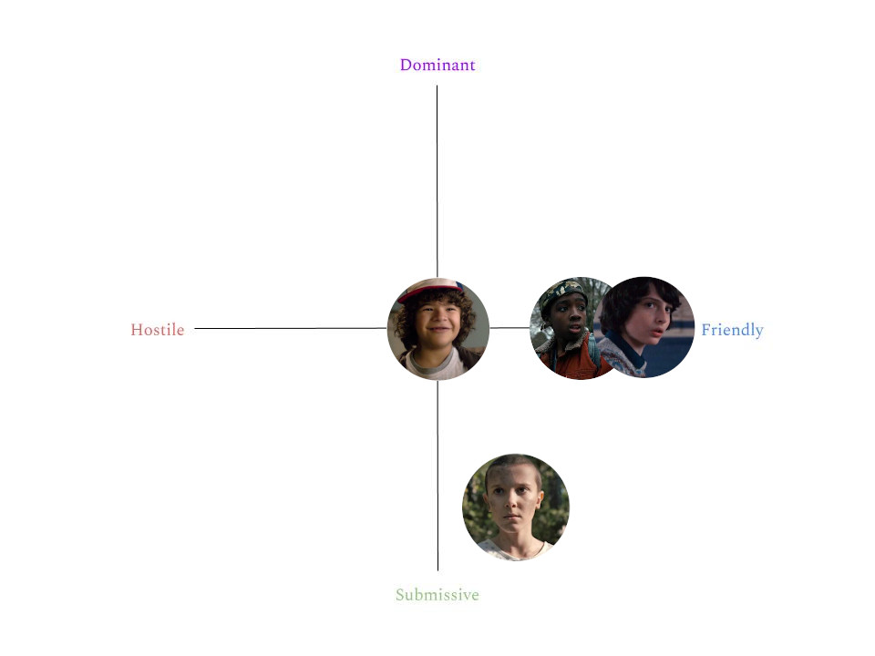
Lucas
Description
Lucas is one of the former members of Mike’s party. As his friends, he attends Hawkins Middle School. He is a black boy, has black short hair and usually a camouflage bandana, a wrist rocket and a utility belt.
He is the most grounded to reality of the group and often refuses fantastical explanations for
complex situations. Lucas was the most adverse to Eleven, presumably for the very reason
that she represents the supernatural. He acts as the more pragmatic and logical one, but usually he over-complicates situations. His hobbies are riding bikes, playing video games, and shooting his wrist rocket.

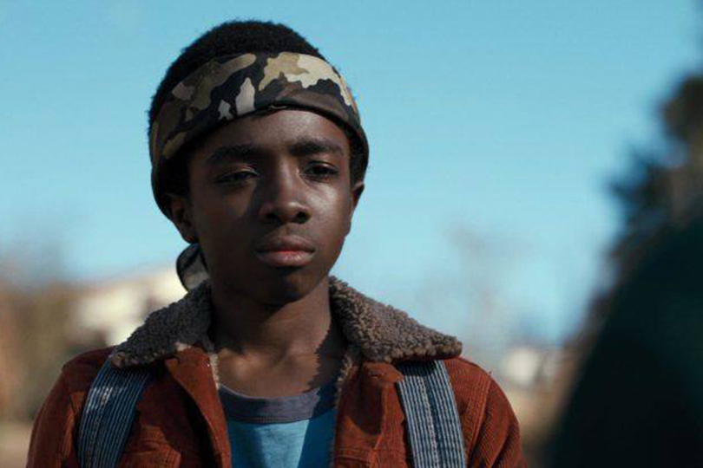Lucas in his typical outfit.
Credits: Netflix.
Circumplex
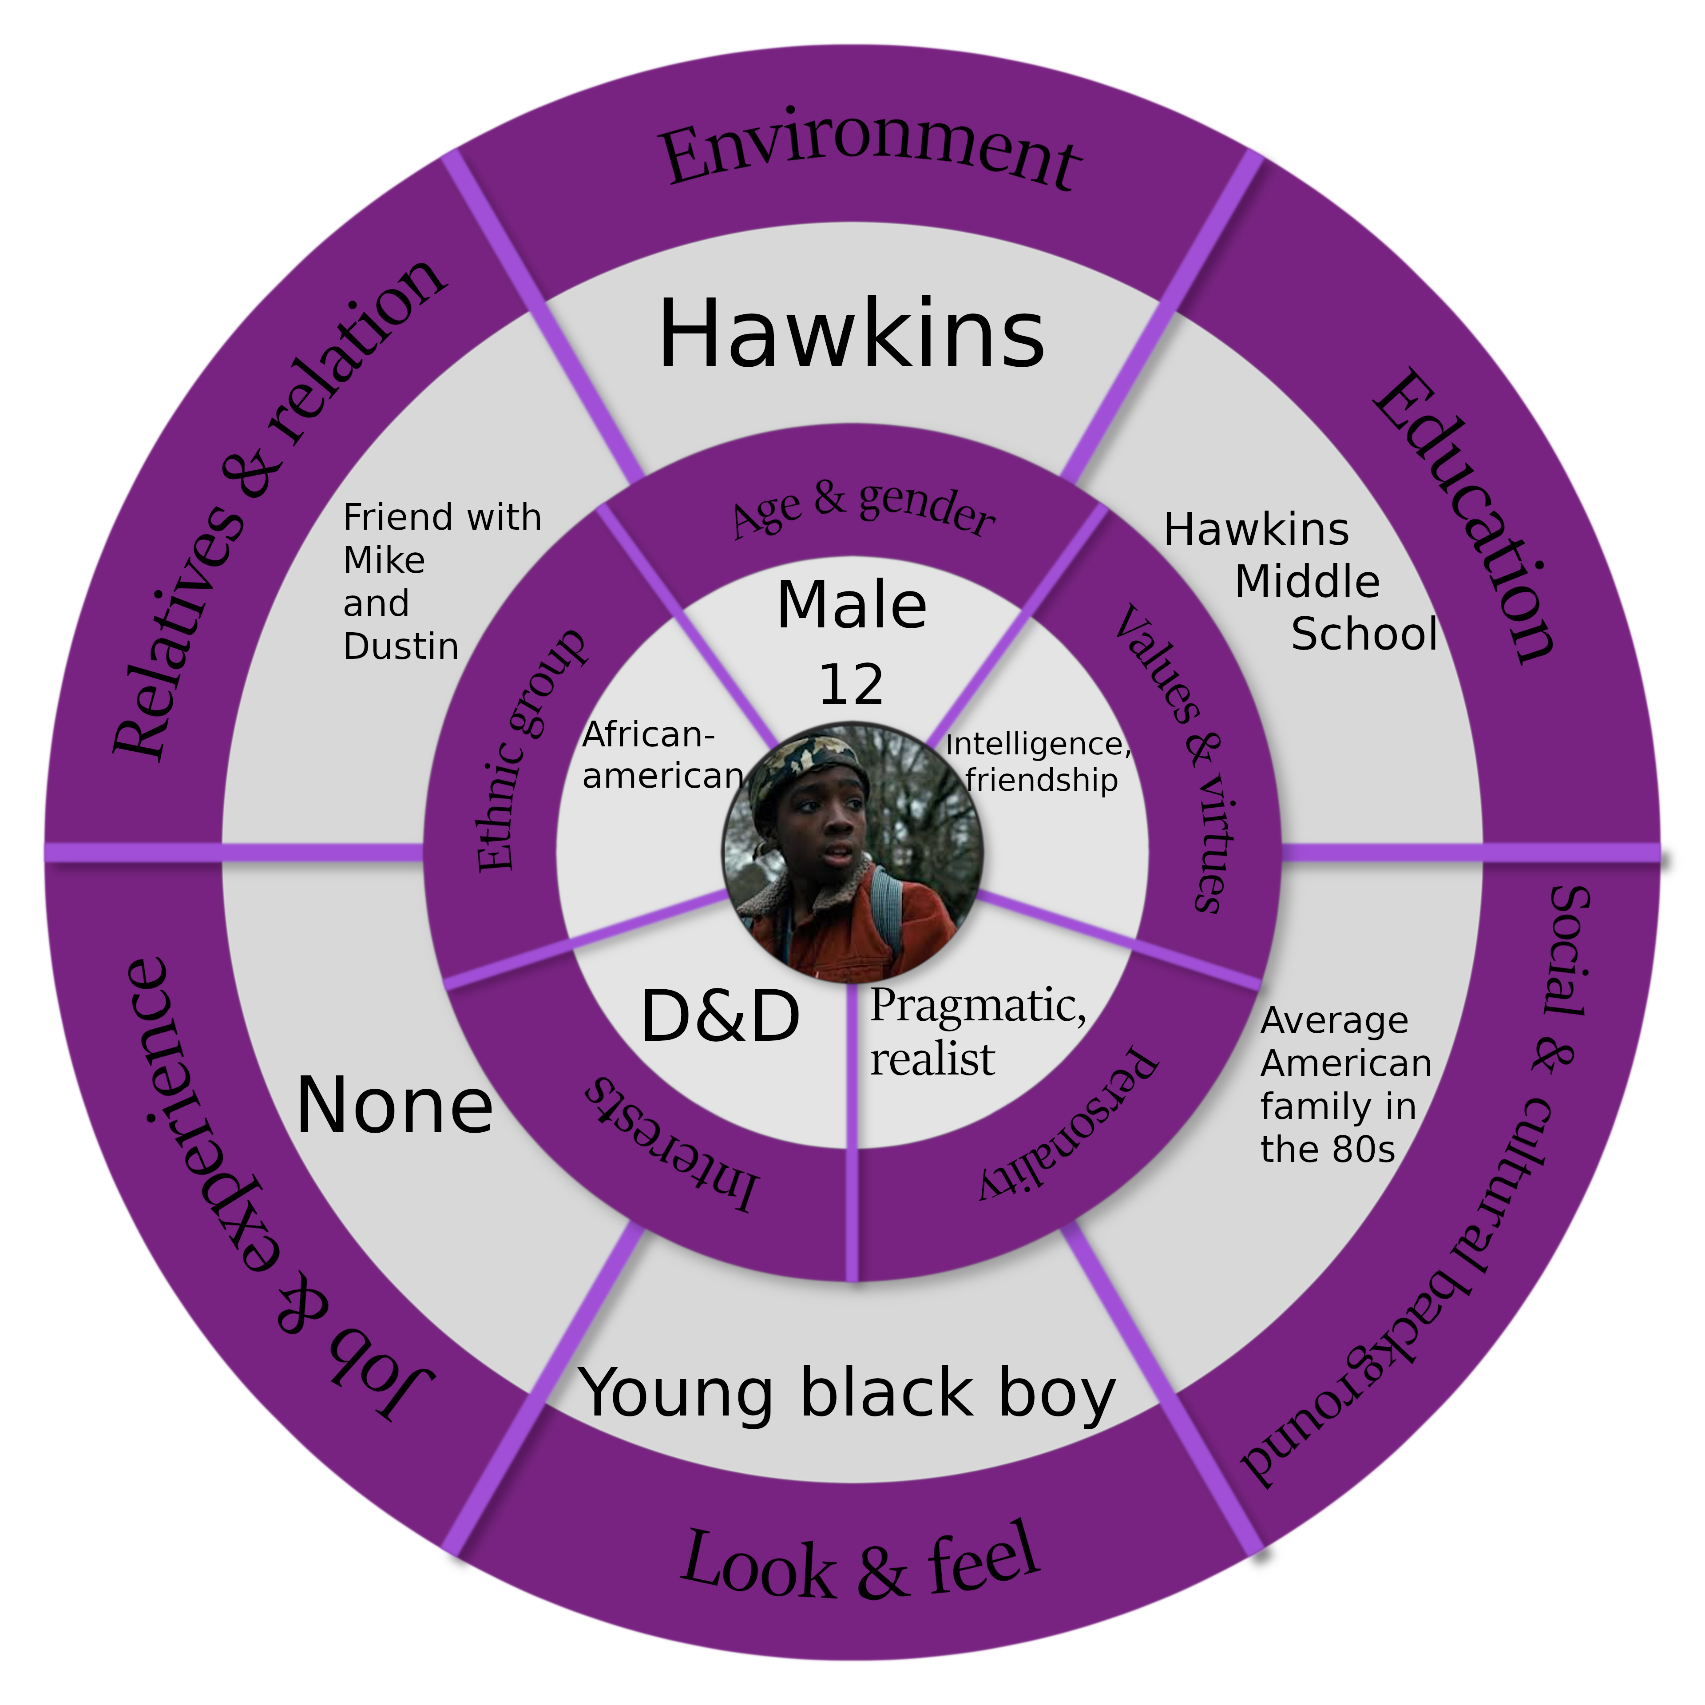

Relationships Map
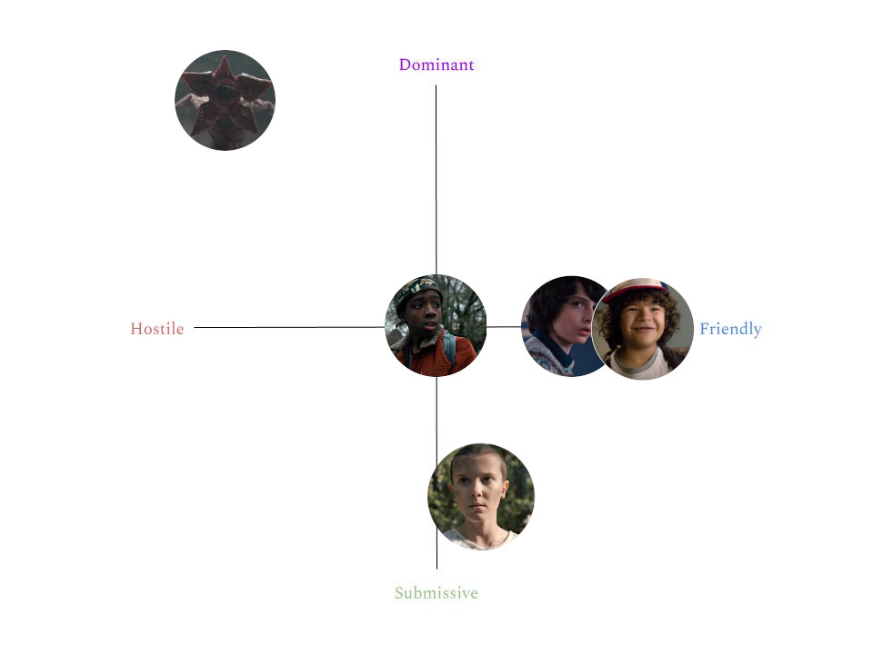
Demogorgon
Description
The Demogorgon is a predatory monstrous creature of the Upside Down which has the ability to travel between dimensions on a whim, creating temporary portals in the fabric of reality. It also possesses an incredible sense of smell which allows it to easily track down a prey in miles.
Its thin humanoid aspect is deeply unsettling because of the lack of facial features; in fact, it can unfurl what it has for a face to reveal petal-shaped flesh lined with many sharp teeth and an enormous mouth. Its arms and digitigrade legs end in claws and its ashy skin is clearly slimy.
It’s covered in burn wounds after its previous encounters with the group in the series, and it emits guttural growls and shrieks. It appears to also influence the lights in the area where it lurks, making them flicker.

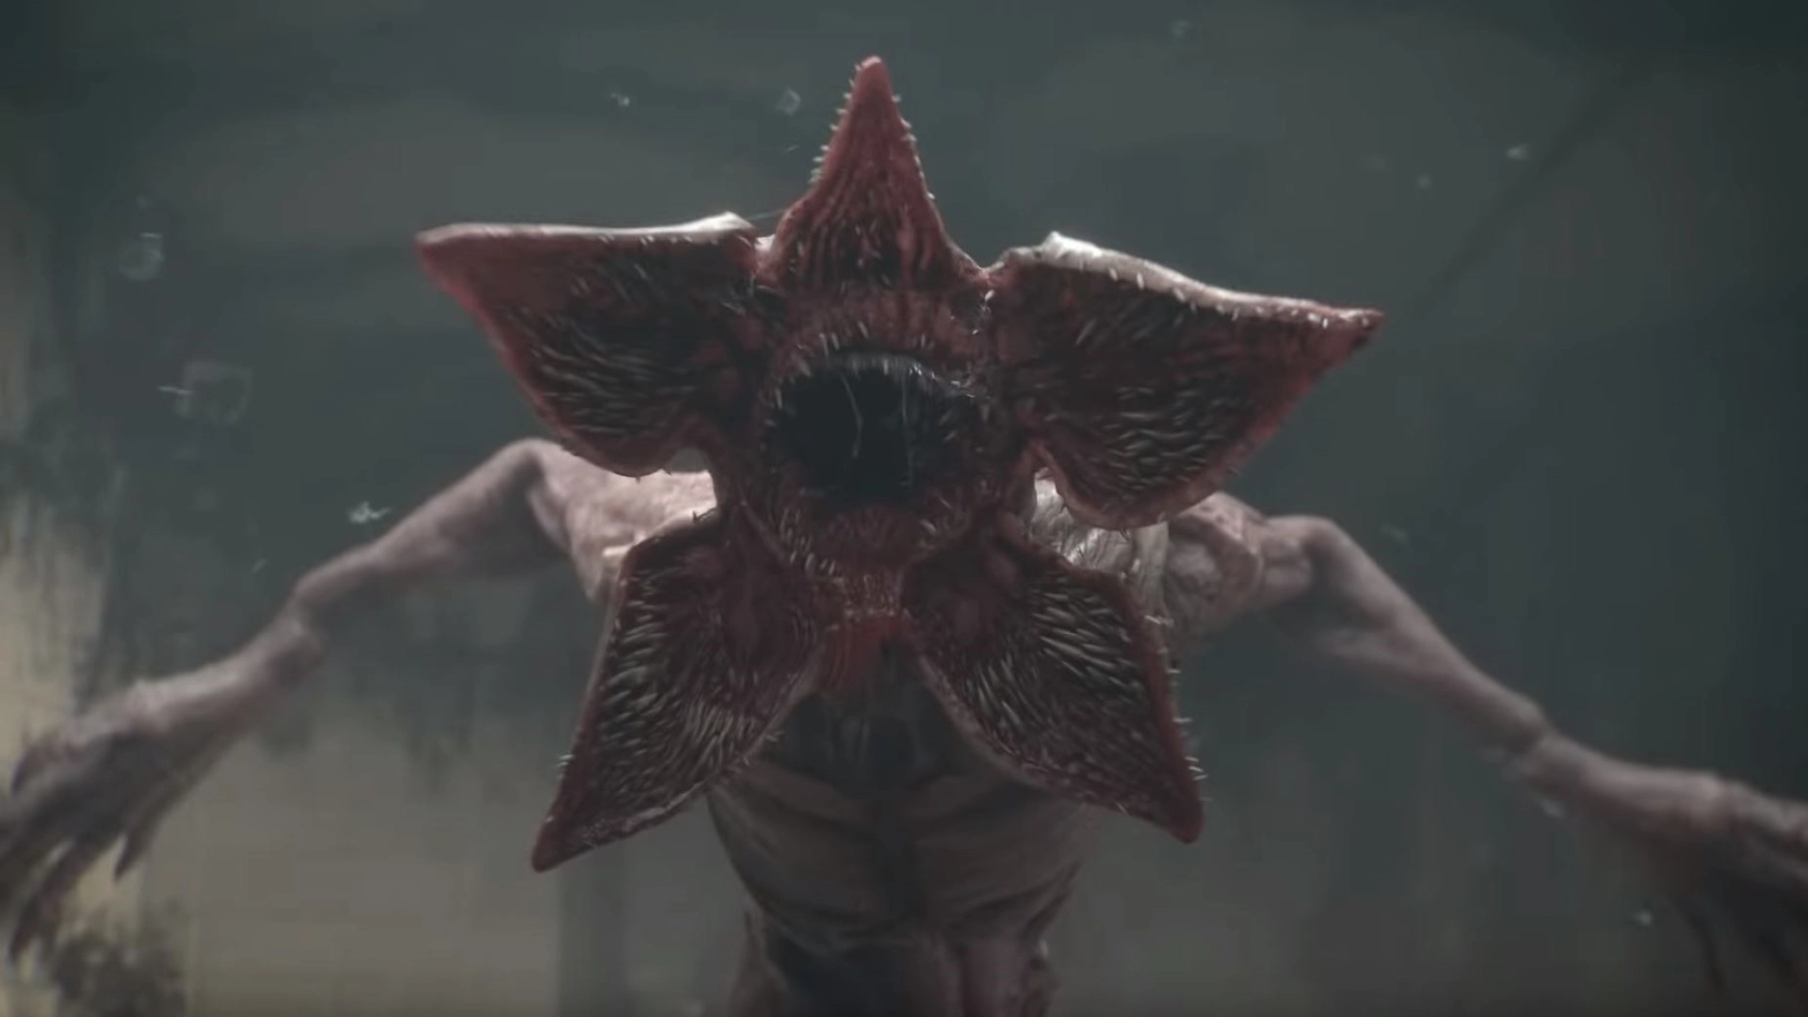The Demogorgon with his face open.
Credits: Dead by Daylight - Stranger Things Chapter.
Circumplex
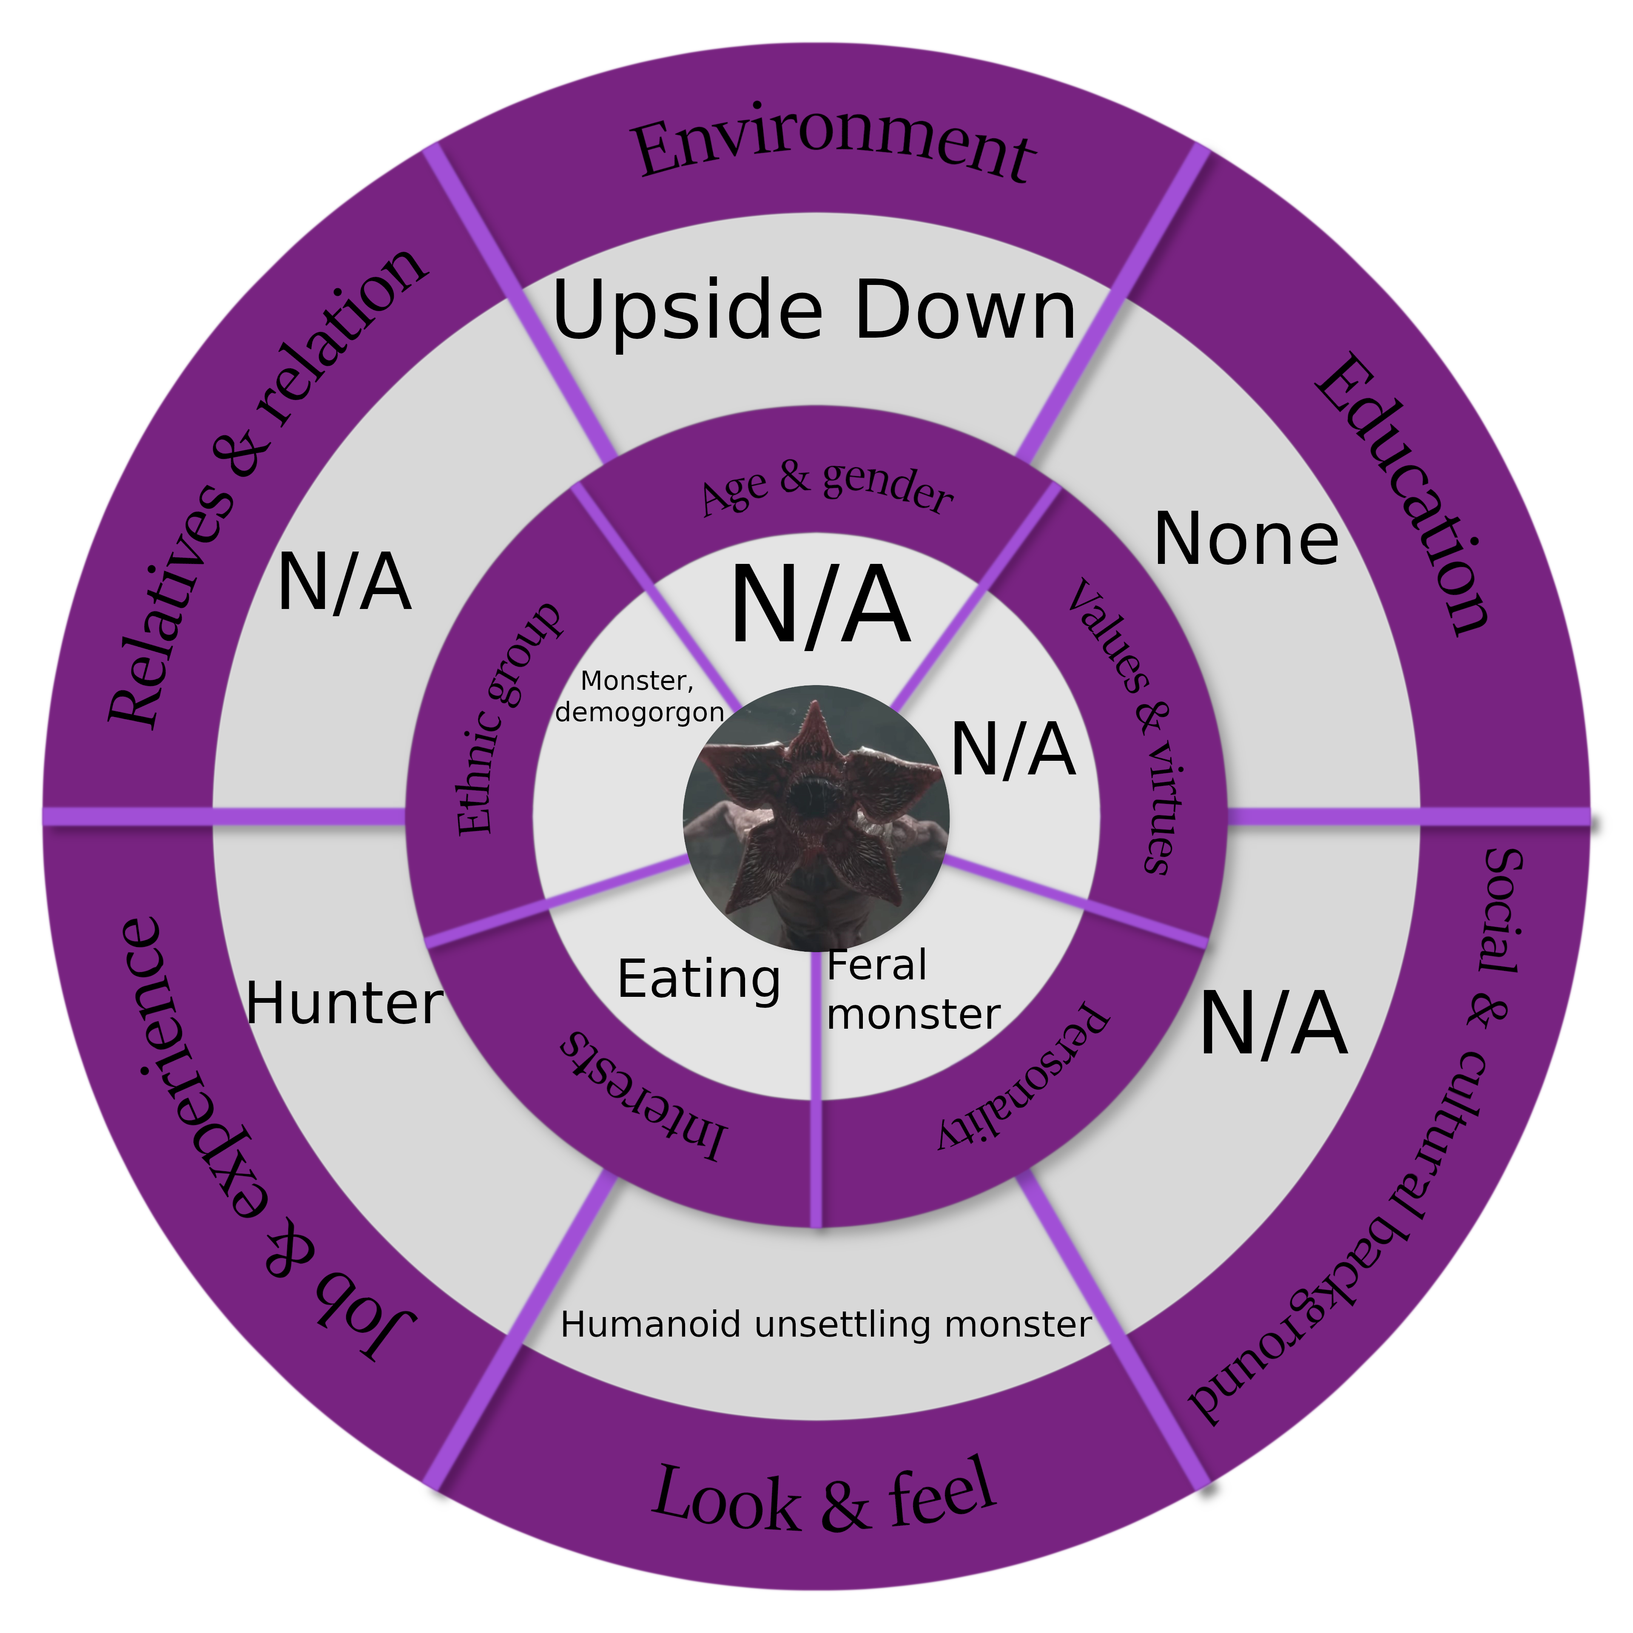

Relationships Map
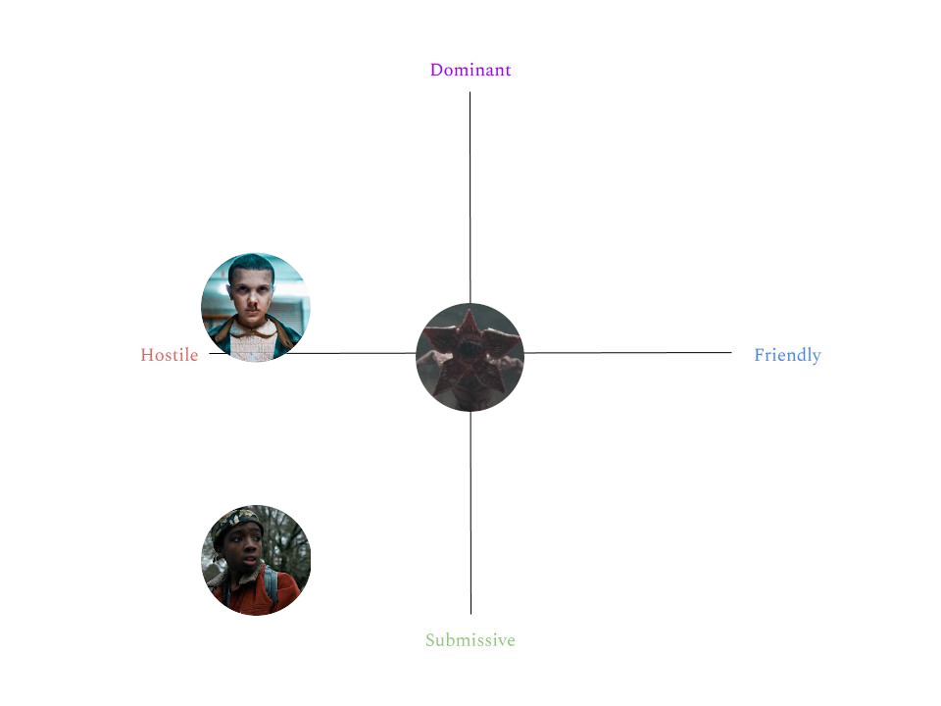
Corrupted Eleven
Description
What remains of Eleven after she started to succumb to her own fears. Her physical aspect is morphing into that of the Demogorgon, and she gains new abilities because of this: for example, she is able to traverse space through tunnels carved into the fabrics of reality like the monster. She should be seen as the part of Eleven that wants her to step back from human encounters and remain lonely and isolated. In fact, this is what Eleven becomes in the exact moment she gives up on trying to overcome her fears. Nevertheless, this is an important part of Eleven’s mind, being the fact that Eleven needs fear and caution to be safe. She looks dirty, her limbs are becoming longer, her skin is turning even more pale and seems viscid. In the scene where the focus switches from Corrupted Eleven to Pure Eleven, her aspect is almost completely morphed in something that resembles the Demogorgon.

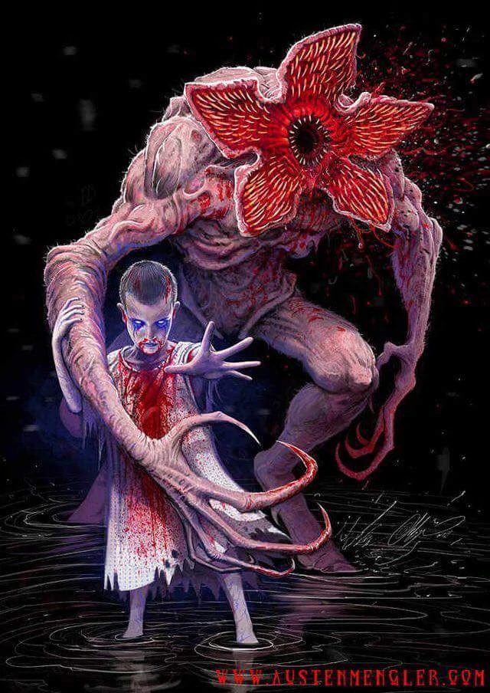Corrupted Eleven, during and after her transformation.
Credits: Austen Mengler.
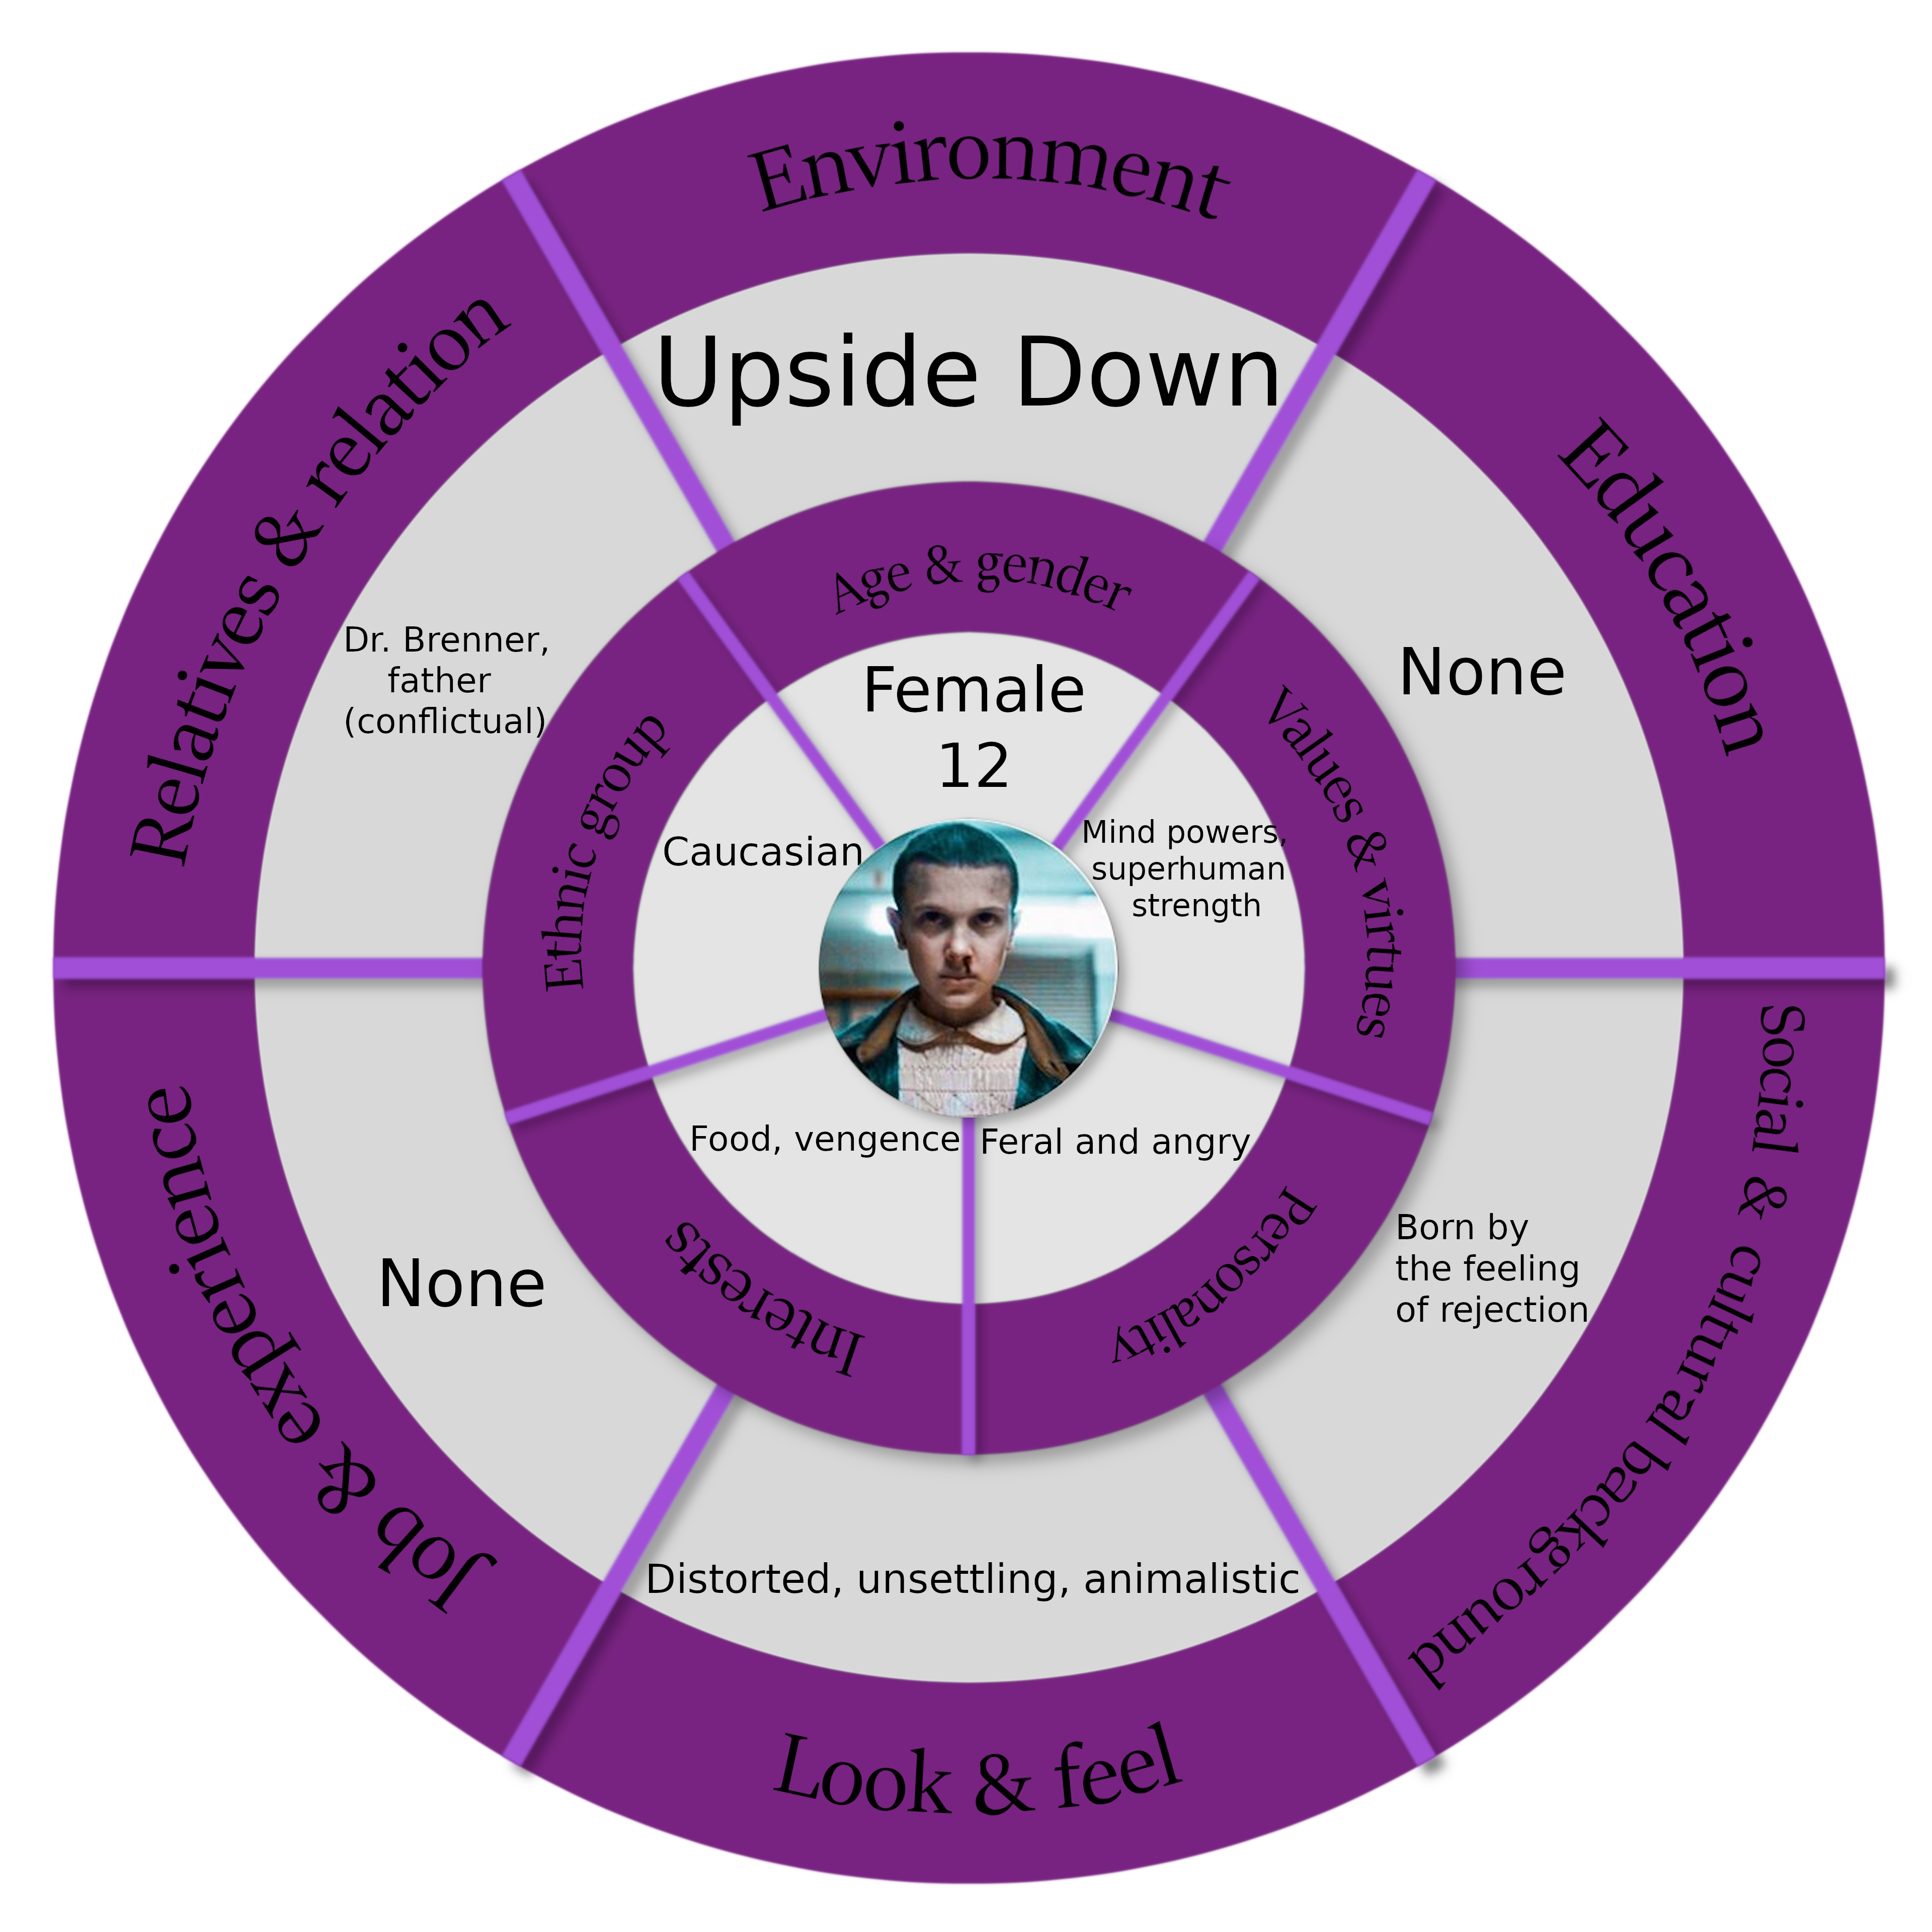
Circumplex

Relationships Map
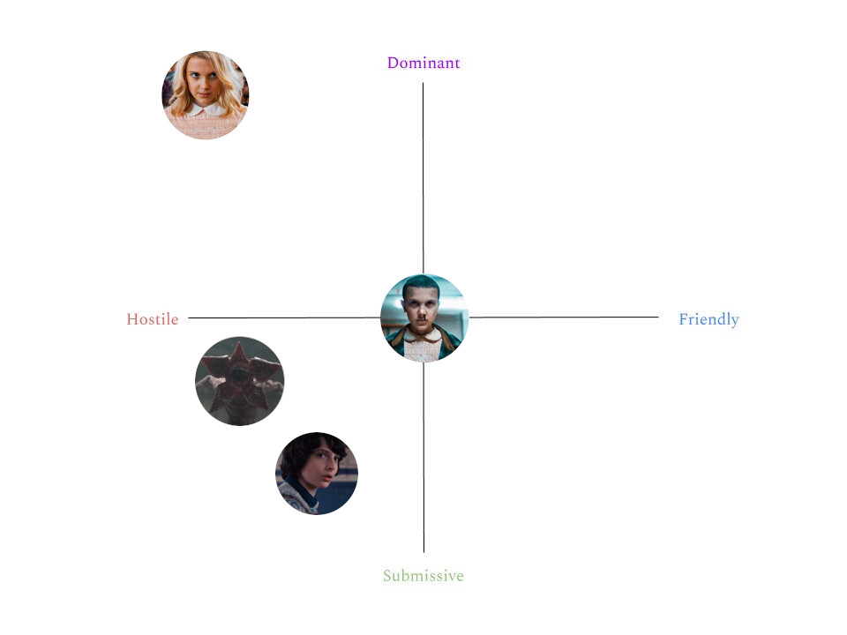
Pure Eleven
Description
A mirror copy of Eleven, sprouted like an angelic flower from the single tear Eleven shed after killing Mike. She is the representation of the more empathetic and human remains of Eleven’s now fragmented and messy mind. She should be regarded as the main reason Eleven searches for human contact and cares for her new friends. She however should not be seen as the perfect Eleven, just as one of the two conflicting parts of her mind. She is dressed in a white and luminous dress, she has long and blonde hair and evokes a feeling of purity and kindness.

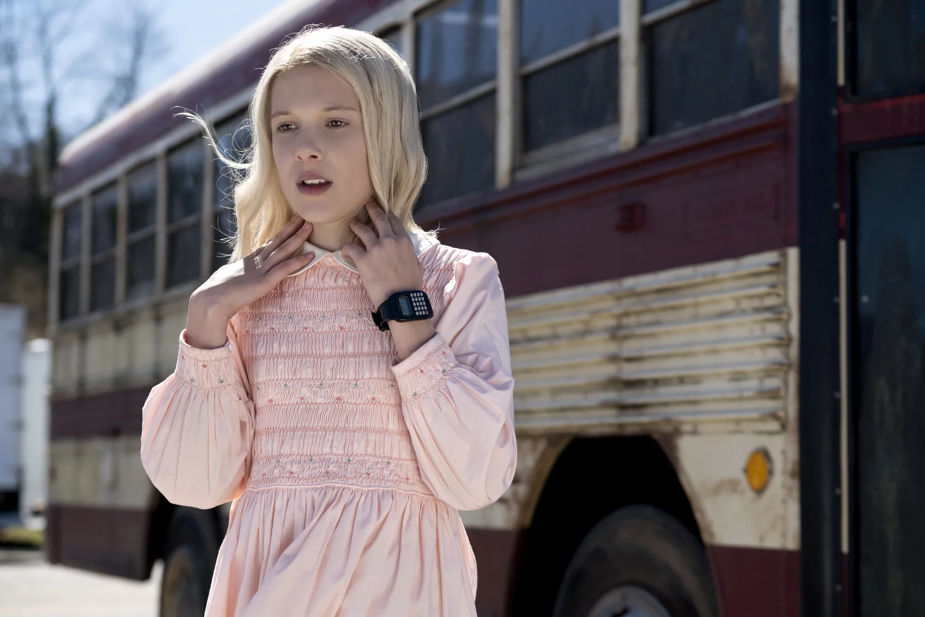Note that Pure Eleven has a white dress and no watch on her wrist.
Credits: Netflix.
Circumplex
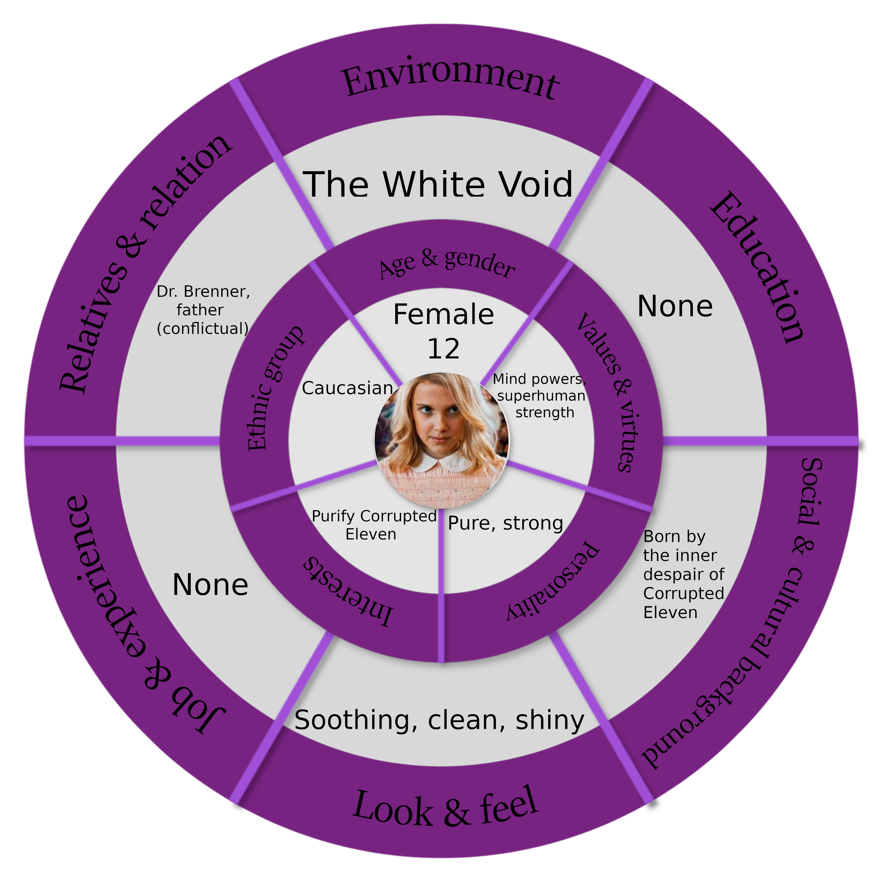

Relationships Map
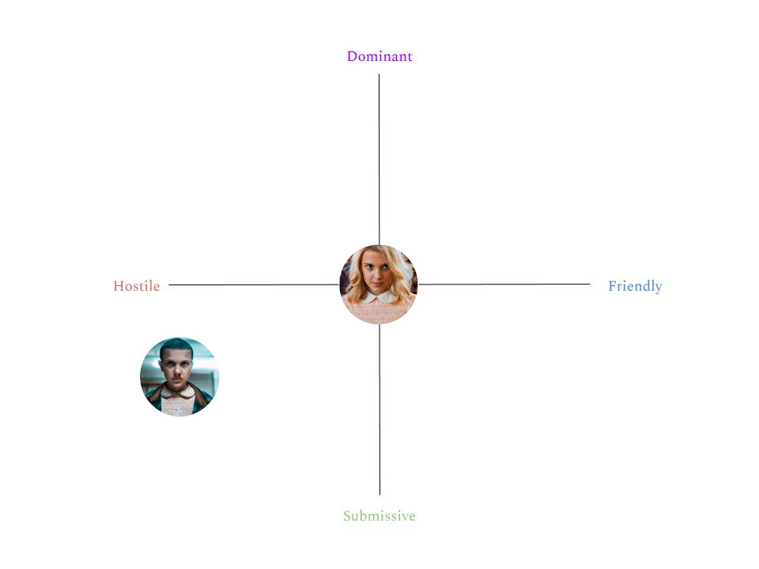
Goal Outline
The first letter of each level name composes the acronym [Catastrophe]
Level 1: Cage.
- Sneak out of your room.

Level 2: Abusive.
- Explore the laboratory and find a way out.
- Fight Dr. Brenner.

Level 3: Troubles.
- Escape from your friends.
- Reach the school.

Level 4: Alive.
- Find a way out.
- Don’t get caught by the robots.
- Fight Dustin.

Level 5: Sunken.
- Escape the dungeon.

Level 6: Trash.
- Listen to what they are saying.
- Reach Lucas and Mike.
- Fight Lucas.

Level 7: Roll.
- Chase the Demogorgon.
- Reach Mike’s house to ask for help.
- Search for the keys to the Underworld.
- Fight Mike.

Level 8: Otherworldly.
- Defend yourself from the monsters.

Level 9: Predator.
- Find the Demogorgon and save Lucas.
- Kill the Demogorgon that’s eating Lucas.

Level 10: Helpless.
- Kill Mike.

Level 11: Eleven.
- Ķ̷̆Î̴̲́L̸̤̈́L̴̜͆ E̵͇͐͝L̵̮͗̈Ẽ̶̤͎V̵̛̞̲͆E̶͖̓Ṋ̴̘̈
- s a v e e l e v e n
Level 4 – Alive

Level story overview

The level before this one ends with Eleven that, after being chased through the pumpkin patch, loses Mike, Dustin and Lucas for a bit, and finds shelter inside the Hawkins Middle School.
This level starts with Eleven that barricades herself into the school, using her powers to throw a locker in front of the main entrance, blocking it. The lighting of the area is warmer in the first part, opposed to the cold tones used before, to symbolize how she feels safer now that she’s not chased anymore.
After a bit, she hears the boys trying to brute force their way in with no success; Dustin then begins to say how they should leave and let him work, so he can capture their prey. During this dialogue, the light starts shifting again to a colder scale, and so does the calm ambient music used in the first section: it’s now more suggestive and anxiety-inducing, but it is not at its peak yet.
Eleven then notices that the source of light that filters trough the opaque glass of the entrance door is now blocked, not entirely, by an ominous looking figure that emanates a robotic/metallic sound. Understanding that she can’t escape from the same way she came from, Eleven starts wondering where she could find a way out. She recalls an alternative exit situated in the south hall, and starts heading that way.

Suddenly, the sound of heavy steps not so distant from her and a bright red light coming from her right get her scared. Dustin voice starts rasping through the speakers, announcing how he flooded the school with his high tech robots to capture her. Panicking, she finds cover behind the acceptance desk: the heavy steps reveal a big robot with a siren implanted over his head. It starts walking around and enters in a nearby classroom: inside, the robot notices a mannequin and starts making a high pitch sound that catches the attention of other robots in the area. All together they start ripping apart the mannequin, making sure that both Eleven and the player understand how dangerous they are, and that a stealthy approach is required against this foe.
Now, Eleven sneaks past them thanks to the free space that opened up because of the alarm that went off: after traversing a tortuous path (and trying to open up windows on the way to escape, but with no success), she reaches the destination, only to find out that it’s blocked by a robot on the other side. Contemplating on what to do next, she gets almost caught by a robot that’s patrolling the area: she quickly reaches for a cover inside an open locker not too distant from her, and watches the robot passing in front of her trough the small grate of the locker. When the hall is clear, she exits the locker, and starts to ponder where to go next.

She opts for the gym: she recalls how, when she was there with her friends, she noticed some windows that led outside. Since they are placed up high from the floor, she thinks that maybe they are not blocked like the other ones throughout the building.
She starts crouching around, searching for the right path to follow, but finds the stairs that lead to the gym in the lower floor blocked by some robots that don’t seem keen to move in the foreseeable future: searching around for a bit, she finds a hole in the floor that leads to a locker room downstairs, with some benches, trophies and sport equipment inside. Eleven then decides to jump down, landing in the room below: upon trying to leave the room, a cutscene will start.
A robot, patrolling down the hallway, is heading directly towards her: scared, she shuts the door, not thinking about the noise she will make. The robot, that hadn’t even noticed her yet, gets alerted by the sound and decides to enter the room to check. Here, Eleven should try to use her powers to throw something (like a trophy or something heavy) at the siren on the top of the robot’s head, or perish by its hands when eventually it finds out she’s inside the room and starts making the high pitch sound the player heard in the beginning of the level from the first robot. After this mini bossfight Eleven is free to keep heading to her final destination, the gym.

Once she reaches the location, she sees that one of the big windows on the other part of the gym is open, and that there isn’t any surveillance here: she begins to run to the window, happy that’s she’s almost out, just to be stopped by Dustin entering the gym. He mocks her for how she thought she could so easily escape, telling Eleven that she fell right into his trap. Here, a bossfight starts: Eleven has to survive a determined (but only hinted at by environmental clues) amount of time. She will not try to hurt Dustin: instead, she will try to talk to him, reminding him of their friendship.
Once the time is up, the second phase will begin, and Dustin will call for aid with a remote control: the ceiling breaks and D.U.D. (or “Dustin’s Ultimate Droid”, as defined by Dustin himself as the robot lands) joins the fight. This robot has a different appearance compared to the surveillance robots in the rest of the level: it’s a taller, bulkier, more polished and armed version of the standard robot of the level. Now, apart from dodging Dustin projectiles, she has to deal with this double threat for another fixed amount of time: even if now she’s allowed to hit D.U.D., she’s not allowed to hit Dustin because she doesn’t want to hurt him, she wants him to forgive her for what she has done.
When the hidden timer is over, Eleven notices that the walls, weakened by Dustin’s hits, are starting to crumble: a big piece of ceiling is also falling on Dustin head, and she tries to leap forward to save him. Unfortunately she’s not fast enough and he gets crushed by it. A few moments later the entire school starts to deteriorate, collapsing on itself, and when the floor breaks under Eleven’s foots, she finds herself free-falling: when she finally reaches the floor, Eleven hits her head on something, passing out on the spot.
Voice lines

“It's blocked. I have to find another way around” -Eleven, upon reaching a dead end.
“There is a hole in the floor! I could use it to reach the gym.” -Eleven, after the discovery of a hole.
“Argh, it was close! I have to be careful.” -Eleven, after being nearly busted by a robot.
“One less problem, ninety-nine more to go” -Eleven, upon defeating the robot in the locker room.

“Leave this brat to me. I'll catch her in no time!” -Dustin, to Mike and Lucas.
“Emh, I just wanted to warn you: I flooded aaaaall the school with my high-tech robots. You. Are. Not. Getting. Out. Alive.” -Dustin, the first time he talks through the speakers.
“Mhh, show up already! Man, you're so boring... no wonder why nobody likes you.” -Dustin, annoyed by Eleven's behavior.
“Where do you think you're going? Ah ah ah. You fell right into my trap.” -Dustin, as he reaches Eleven in the gym.
“Say hello to my little friend, Dustin's Ultimate Droid! Or as I call it, D.U.D.” -Dustin, as he uses the remote control to summon D.U.D.
“My baby! I worked hard on that!” -Dustin, after Eleven destroys one of his turrets.

“Fired up and ready to serve.” -D.U.D. when summoned by Dustin.

